Training model using Roboflow :

https://wiki.seeedstudio.com/YOLOv5-Object-Detection-Jetson/#annotate-dataset-using-roboflow

ROBOFLOW – DATASET

ROBOFLOW :
Roboflow is a computer vision platform that allows users to build computer vision models faster and more accurately through the provision of better data collection, preprocessing, and model training techniques.

STEP 1 : Create Project – Dataset
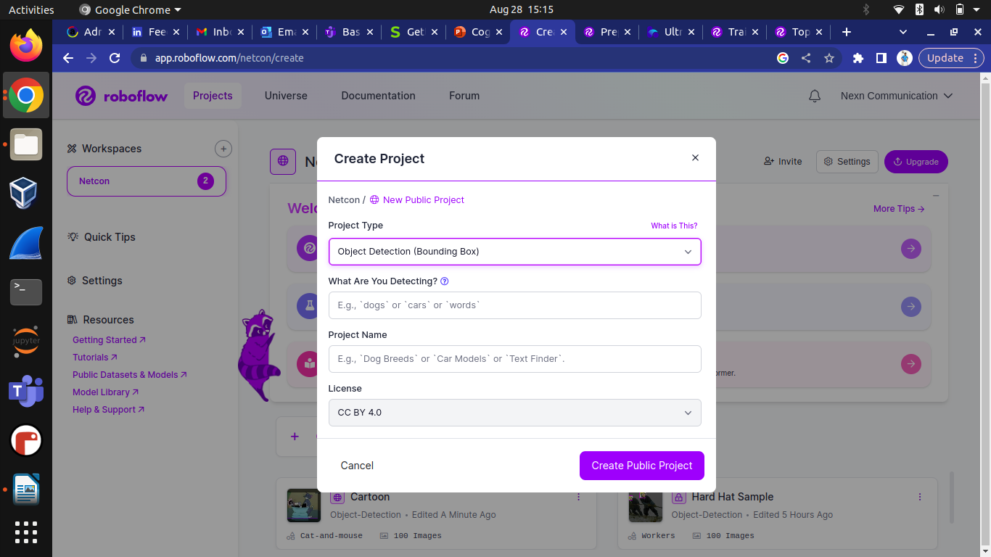

STEP 2 : Upload or drop (images or Video) ,set framerate as required (for ex: uploaded video and set 1 frame as per second)

STEP 3 : After the video is converting in frame ,then we want to annotation the object in the frame . For Example :
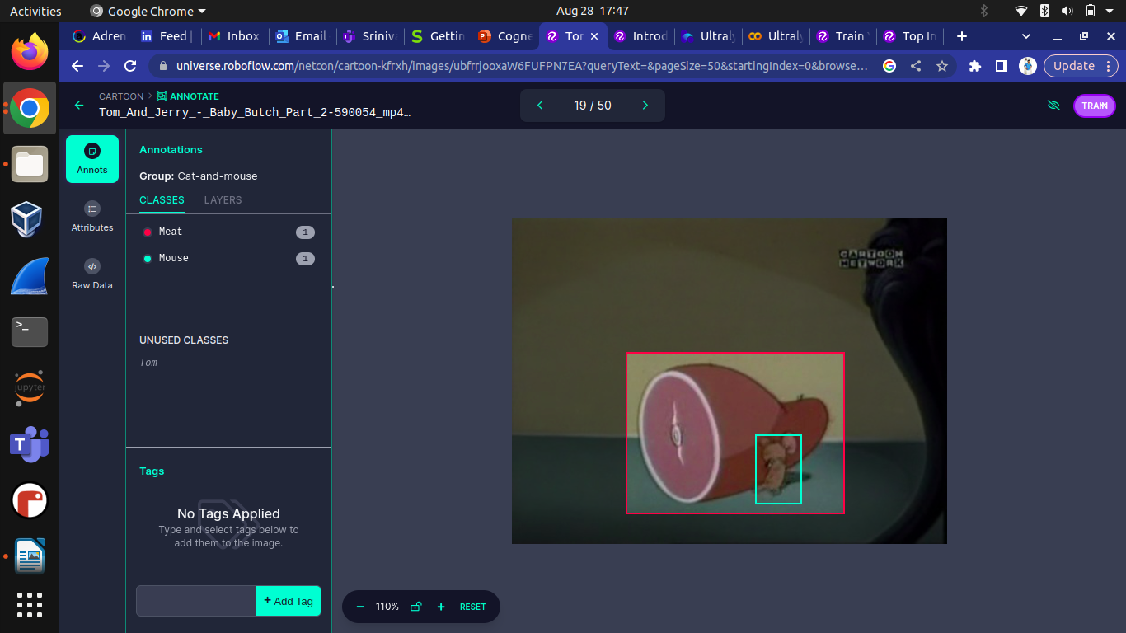

Green indicates – Mouse and Red indicates – Meat

STEP 4 : After completed annotation for all the object in datasets, Then , there option like preprocessing , Augmentation addition feature ,if required you may add in dataset and finally generating Dataset. For More details

Refer link :- https://docs.roboflow.com/

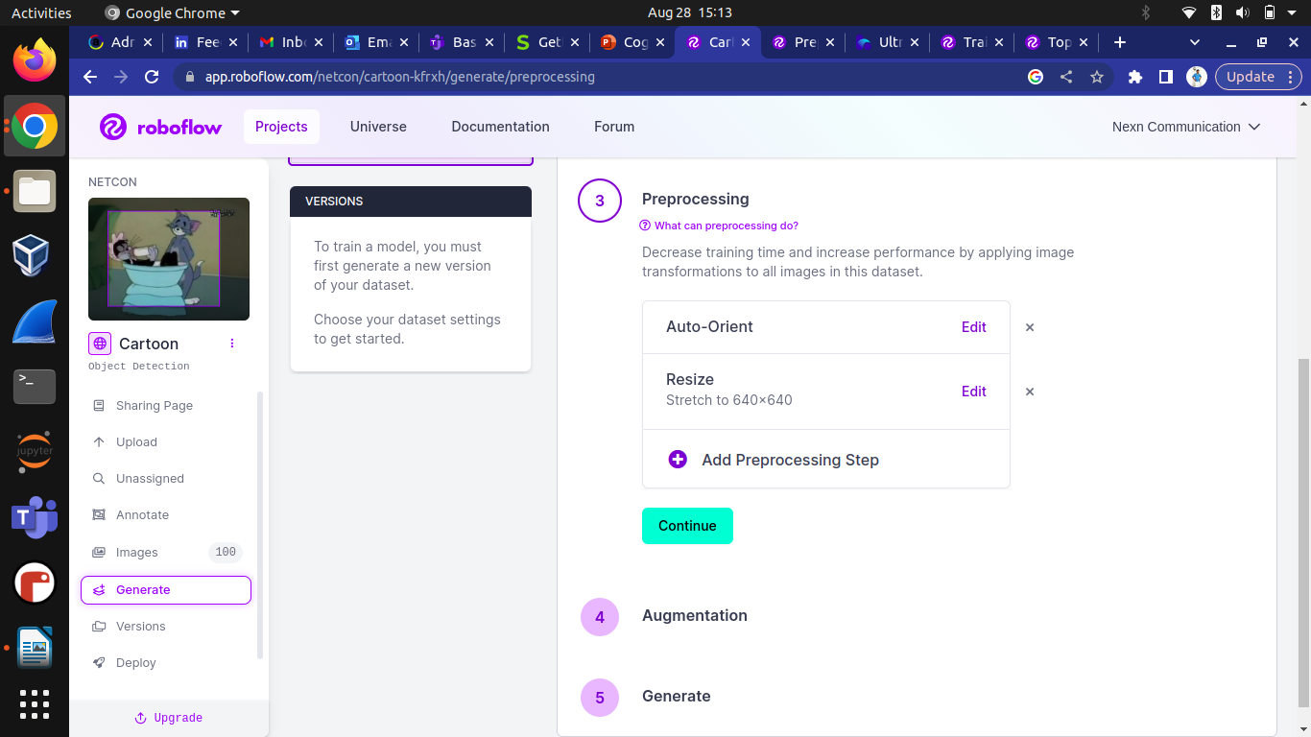
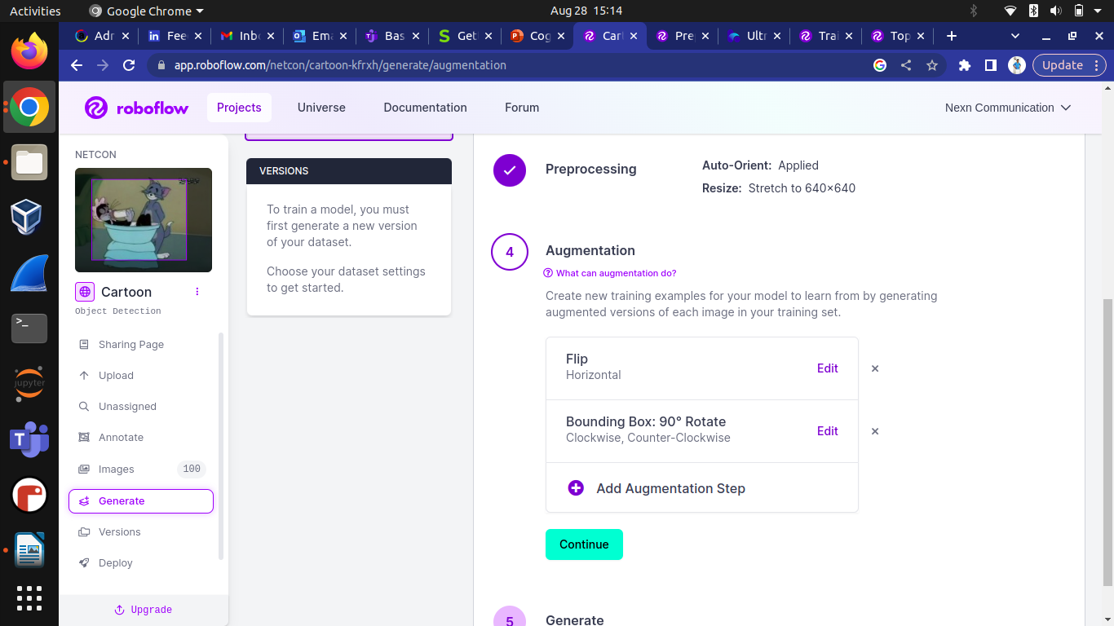

STEP 5 (a) : After generating the dataset , It splits the dataset into train_set , Valid_set , test_set .
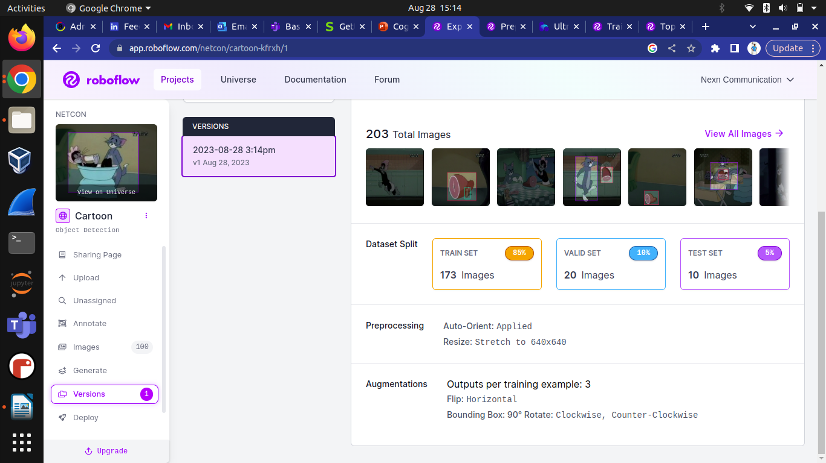
STEP 5 (b) : Below images show that the pictures in the datasets has been successfully trained .

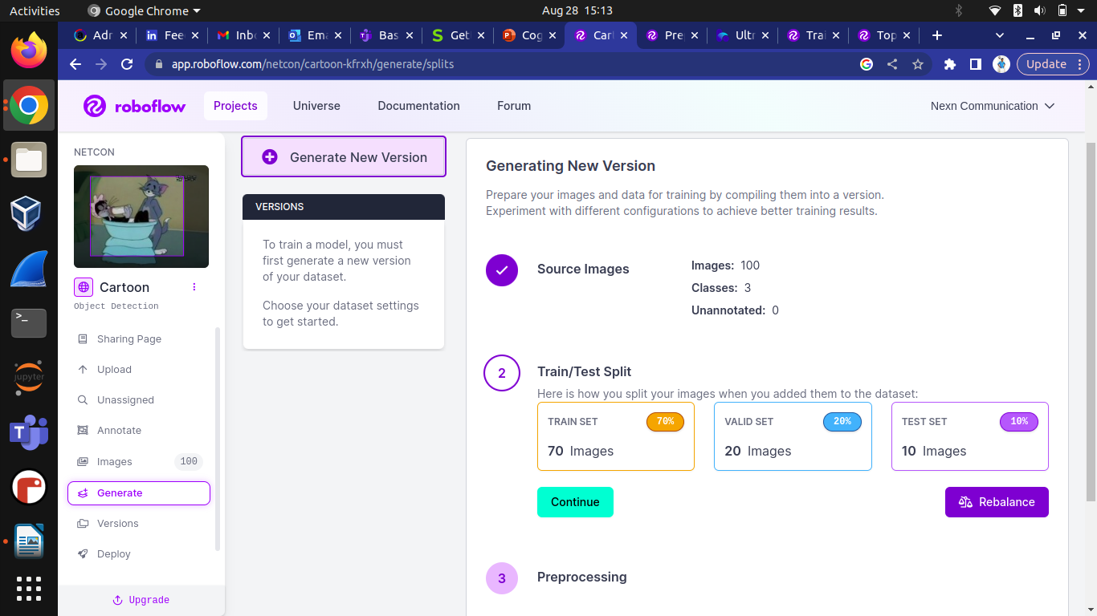
STEP 6 (a) : You can view and verify the train_set , Valid_set , test_set in the dataset ,if required you can reset and train the dataset again .
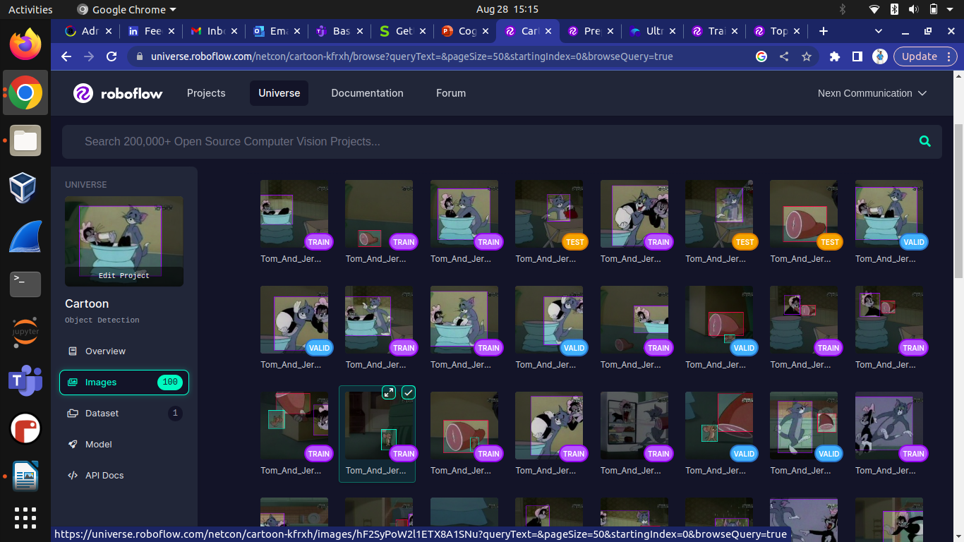
STEP 6 (b) : Finally dataset is ready to deployment in the Ultralytics to create the model .

